

**Smartcards Autorization Oficcer**

Índice

1. LMK 3

1.1. Formatar 3

1.2. Criar 4

1.3. Carregar 4

2. Autorization Oficcer - Console 5

2.1. Formatar 5

2.2. Criar 5

2.3. Autorizar 6

3. Autorization Oficcer – payShield Manager 7

3.1. Pré Requisitos 7

3.2. Criar 7

3.3. Autorizar 7

4. Release Notes 9

# LMK

O exemplo abaixo mostra o processo de criação e gravação dos componentes de uma LMK do tipo Key Block AES. A aglutinação desses componentes forma a LMK.

## Formatar

Formatação dos smartcards para receber a LMK.

|  |
| --- |
| Online>fc  Insert card and press ENTER:  Card already formatted; continue? [Y/N]: y  Format card for HSM SETTINGS/LMKs/KTKs? [H/L/K]: l  Erasing card  Formatting card...  Enter new PIN for smartcard: *****  Re-enter new PIN: *****  Enter time [hhmmss]: 104010  Enter date [DDMMYY]: 130421  Enter User ID: ft  Enter Issuer ID: ft  Format complete |

|  |
| --- |
| Online>fc  Insert card and press ENTER:  Card already formatted; continue? [Y/N]: y  Format card for HSM SETTINGS/LMKs/KTKs? [H/L/K]: l  Erasing card  Formatting card...  Enter new PIN for smartcard: *****  Re-enter new PIN: *****  Enter time [hhmmss]: 104210  Enter date [DDMMYY]: 130421  Enter User ID: ft  Enter Issuer ID: ft  Format complete |

|  |
| --- |
| Online>fc  Insert card and press ENTER:  Format card for HSM SETTINGS/LMKs/KTKs? [H/L/K]: l  Erasing card  Formatting card...  Enter new PIN for smartcard: *****  Re-enter new PIN: *****  Enter time [hhmmss]: 105810  Enter date [DDMMYY]: 130421  Enter User ID: ft  Enter Issuer ID: ft  Format complete |

## Criar

Processo de criação dos componentes da LMK. Os componentes são criados e gravados nos smartcards.

|  |
| --- |
| Secure>gk  Variant scheme or keyblock scheme? [V/K]: k  Enter algorithm type [D=DES, A=AES]: a  Enter the number of components to generate: [2-9]: 3  Enter the number of components required to reconstitute the LMK: [2-3]: 2  Key status? [L/T]: l  Check value for the LMK: 185FC6  Insert blank card and enter PIN: *****  Writing keys...  Checking keys...  Device write complete, check: 18958D  Insert blank card and enter PIN: *****  Writing keys...  Checking keys...  Device write complete, check: DE6FAF  Insert blank card and enter PIN: *****  Writing keys...  Checking keys...  Device write complete, check: 6D9B85 |

## Carregar

Depois de criados os smartcards com os componentes da LMK, o próximo passo é o processo de carregamento da LMK no HSM.

|  |
| --- |
| Secure>lk  Enter LMK id [0-1]: 0  Enter comments: key block  Load LMK from components or shares  Insert card and press ENTER:  Enter PIN: *****  Check: 18958D  Insert card and enter PIN: *****  Check: DE6FAF  LMK Check: 185FC6  LMK id: 00  LMK key scheme: KeyBlock  LMK algorithm: AES-256  LMK status: Live  Comments: key block  Confirm Details? [Y/N]: y  Use the LO/LN command to load LMKs into key change storage. |

# Autorization Oficcer - Console

## Formatar

Processo de formatação dos dois smartcards que serão utilizados como Authorization Office.

|  |
| --- |
| Secure>fc  Insert card and press ENTER:  Format card for HSM SETTINGS/LMKs/KTKs? [H/L/K]: l  Erasing card  Formatting card...  Enter new PIN for smartcard: *****  Re-enter new PIN: *****  Enter time [hhmmss]: 133513  Enter date [DDMMYY]: 130421  Enter User ID: ft  Enter Issuer ID: ft  Format complete |

|  |
| --- |
| Secure>fc  Insert card and press ENTER:  Card already formatted; continue? [Y/N]: y  Format card for HSM SETTINGS/LMKs/KTKs? [H/L/K]: l  Erasing card  Formatting card...  Enter new PIN for smartcard: *****  Re-enter new PIN: *****  Enter time [hhmmss]: 133613  Enter date [DDMMYY]: 130421  Enter User ID: ft  Enter Issuer ID: ft  Format complete |

## Criar

Use o Comando: CO cuja função é copiar a senha de um authorizing officer para outro smartcard de HSM comum (os RLMKs (Smartcards payShield manager com componentes LMK) são suportados) são usados para colocar o HSM no estado autorizado. Observe que apenas LMK dos smartcards de componentes 1 e 2 contêm a senha, portanto para cópia deve ser copiado dos componentes 1 e 2.

|  |
| --- |
| Secure>co  Insert card for component or share set 1 or 2 and press ENTER:  Enter PIN: *****  Insert card for authorizing officer and enter PIN: *****  Copy complete |

|  |
| --- |
| Secure>co  Insert card for component or share set 1 or 2 and press ENTER:  Enter PIN: *****  Insert card for authorizing officer and enter PIN: *****  Copy complete |

## Autorizar

Exemplo da utilização dos smartcards do Autorization Office no processo de autorizar a utilização dos comandos de “admin”.

|  |
| --- |
| Secure>a  Enter LMK id [0-1]: 0  No activities are authorized for LMK id 00.  List of authorizable activities:  generate genprint component import  export pin audit admin  diagnostic misc command  Select category: admin  host console  Select interface or <Return> for all:  Enter time limit for admin, or <Return> for permanent:  Console authorizations will expire in 720 minutes (12 hours).  Make host activity persistent? [Y/N]: y  Enter additional activities to authorize? [Y/N]: n  The following activities are pending authorization for LMK id 00:  admin..console:720  admin..host:persistent  First officer:  Insert card and press ENTER:  Enter PIN: *****  Second officer:  Insert card and press ENTER:  Enter PIN: *****  The following activities are authorized for LMK id 00:  admin..console:720 (720 mins remaining)  admin..host:persistent |

# Autorization Oficcer via payShield Manager

## Pré Requisitos

Ter os smartcards novos comissionados para transformar em autorization Oficcer pelo payshild manager.

Ter a RLMK que são os componentes da LMK divididos em smartcard do payShield manager.

## Criar

Após acionar o Create Autorizing Card coloque o Smartcard payShield manager RLMK com componente 1 após carregar retire o Smartcard.

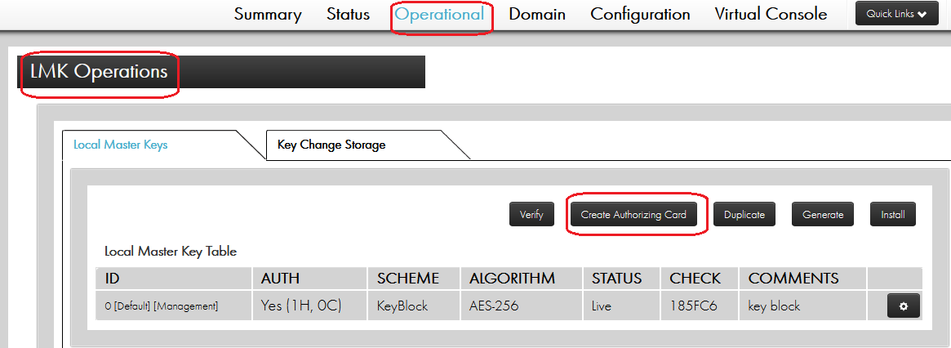

Coloque o smartcard payShield Manager comissionado para receber o componente 1. Repetir o processo para o componente 2.

## Autorizar

Estado autorizado é um modo de operação do HSM que permite um ou mais funções sensíveis possam ser executados. São necessários dois Authorizing Officers para confirmar a atividade usando seus smartcards e PINs.

|  |
| --- |
|  |

|  |
| --- |
|  |

# Release Notes

|  |  |  |
| --- | --- | --- |
| **Autor** | **Descrição** | **Data** |
| Caio Ferreira | Primeira versão | 13/04/2021 |
| Bruno Araujo | Inclusão de texto e revisão | 14/04/2021 |